Game Design Document

10 August 2019

13:44

## Game Identity

Tile-based 2D action platformer with a goal to reach the end of the level without losing all your lives.

## Design Pillars

1. Challenging platforming sections
2. Time pressure
3. Verticality

## Genre/Mechanics Summary

**Genre:**

2D Action Platformer

**Mechanics:**

* The player uses running and jumping to traverse platforms and to avoid traps/enemies.
* Timer presented in a unique way for each level
* Gather collectibles throughout the levels to earn points for a higher score

## Interface

**UI:**

* Player lives
* Player score

**Input:**

* WASD for movement
* Space for jump

## Art Style

* Tile-based pixel art
* Cartoony/uplifting similar to Monster Sanctuary
* Example:
* 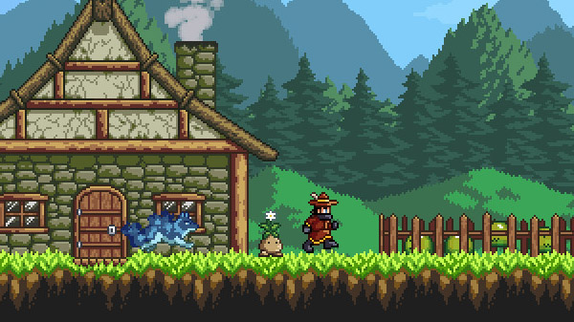

## Music & Sound

**Music**:

* Up-beat with a sense of urgency
* example: <https://www.youtube.com/watch?v=dmsiA8q2_u0&list=PLdj65WIzXe8N7iaVgl_NDV8o8iIGNSYGR&index=37>

**Sound effects:**

* Picking up collectibles
* Losing a life/game
* Completing a level/game

## Development Roadmap

Milestone 1:

* Terrain and player art assets
* A single level with a basic terrain layout
* The player character added to the level

Milestone 2:

* Keyboard input allowing the player to move and jump
* Follow camera for the player
* A second level
* Ability for the player to complete one level and move on to the next

Milestone 3:

* Traps and enemy art assets
* Traps and enemies on the levels
* Player lives
* Able to lose in a level

Milestone 4:

* Collectibles art assets
* Collectibles on the levels
* Point system
* Timer

Milestone 5:

* Main Menu
* Game complete screen
* Game over screen

Milestone 6:

* Music and sound assets
* Background music
* sound effects

Milestone 7:

* Add more levels